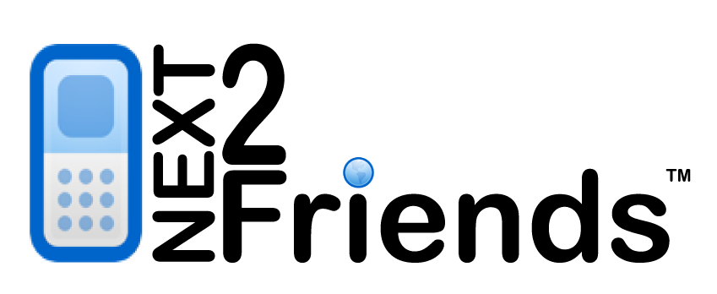

**Lawrence Botley**

**Information Technology for eCommerce**

**Declaration**

This report is submitted as part requirement for the degree of computer science and artificial intelligence at the University of Sussex. It is the product of my own labour except where indicated in the text. The report may be freely copied and distributed provided the source is acknowledged.

**Summary**

Social networking and online dating web sites are amongst the most popular forms of web use amongst web users aged 16-25. This report makes a detailed analysis of existing systems and through this a new mobile device system will be designed which allows users to host a Bluetooth client/server that matches other users in the near proximity when going about daily activities. Matched users are then able to log onto a central web server to view and chat to others who were matched when doing similar activities in the same places at the same time.

This mobile matching system improves on existing social networking by creating a fun and interactive way of meeting people who live and work the same area. The system creates a more personal way of meeting new people than the traditional method of searching large databases of members using keywords and locality options.

The final device application has been designed for Windows Mobile 2003 and uses a purpose built secure binary protocol for Bluetooth communications. Users running the application as a background service can normally be within a 10M proximity of each other for around 3 seconds before both devices communicate and decide whether to match. This is fast enough to match people walking past each other in the street.

Profiles and match filters that are set by individual users are traded to then decipher if each users meets basic criteria such as age and gender. Upon a successful match users are stored locally on the device in XML along with device configuration settings. With a single click users can synchronise their devices with the central server via a binary protocol over HTTP over WAP. Once this have been invoked matches will appear in their account instantaneously where they are given the ability to send messages back and forth allowing personal communication

**Acknowledgments**

Project supervisor **Paul Newbury** for always having his door open and giving me masses of useful information and advice.

1 Introduction 5

2 Design justification 8

3 Requirements 9

4 Design 16

5 Interfaces 26

6 Development practices 34

7 Implementation 36

8 Testing 42

9 System re-evaluation 43

10 Final system design 46

11 Conclusion 58

12 References 59

Appendix 62

**A.6.0 Device design** 110

A.7 White box testing 115

**Items to amend**

* Include details of wireless technologies
* Include details of video compression technologies
* Change intro to include video concepts (infrastructure document)
* Change scenarios + diagrams (from scenarios document)
* Add case studies: Youtube.com, livevideo.com, veoh.com
* Update infrastructure diagrams (already created)
* Add Preventing copyright material to hacks and security section
* Amend Database design
* Add data layer Component API
* Change conclusion
* Talk about Movino + the extensions that will be built into it
* Talk about Flash + Red5

# 1 Introduction

Introduction Live TV and Bluetooth

YouTube.com blah blah blah

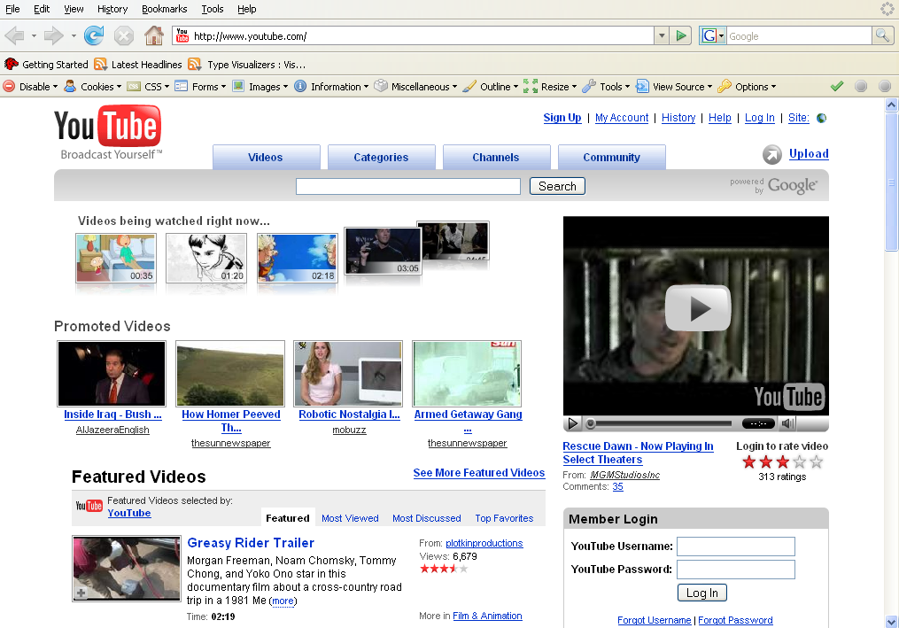

There is another solution; almost all mobile phones on the market today have an API for software development. The symbian operating system is a joint collaboration between Ericsson, Nokia, Panasonic, Samsung, Siemens and Sony and is responsible for vast coverage of the market. The platform executes native code written C++ and supports J2ME, the java micro edition virtual machine. Microsoft have their adaptation of windows in their smart phone edition of Windows mobile which will also execute intermediate code (written in languages such as C#) for the .NET compact framework.  
  
Bluetooth chips are small, low voltage, short range radios and provide a communication services such as object transfer and audio streaming between other Bluetooth devices. Bluetooth chips are becoming more common amongst hand held devices.

Antero Taivalsaari, a core designer for the j2ME platform speaks about the growth of J2ME embedded mobile devices and says "It is fairly safe to forecast that there will be at least 500 million J2ME-enabled devices in the world by the end of 2006".

* 1. **The concept**

The system comprises of a mobile phone real time streaming application, a centralized real-time streaming server and a web application server that streams live video and audio feeds to a web browser client encapsulating a multimedia video player such Macromedia flash or Microsoft’s Silverlight.

Users of the mobile application are able to record live video streams from the camera in their mobile phone. This is achieved by encoding the video stream into a real time streaming codec and is then streamed to a video server over a real time protocol (RTP) using the mobile phones internet connectivity such as GPRS or WIFI connection. Once the video stream has is being transmitted to the server it is then published to end users who can view the video from within their web browser. This will enable users of the web site to view a mobile stream and view the live video being streamed from the end mobile phone user. The system will allow multiple users to view the same stream.

End users will be able to use the system to perform the following tasks

* n-way video conferencing using their web browser to view the other person(s)
* Record their own Live TV channel to be viewed by anyone via their web browser
* Allow viewers to switch channel to view alternative angles (when other angles are present)

# 2 Design justification

A background analysis has been performed on existing systems of relevance and can be found in the appendix under section A.1. The design justifications section takes the conclusion form this analysis and puts forward a case to the design of this system.

**Talk about youtube and live video and veoh.com**

**Introduce movino and explain why it is so good!**

MeetingPlaces’ unintuitive device interface, badly designed web site and less than useful service makes the system only really a proof of concept program that has no real application.

Whilst Bedd’s system is more graphically appealing it again seems to be a badly designed program that serves no real practical purpose and is trying to be a jack-of-all-trades and master of none. Proxydating.com’s software moves a little more towards being practical by firstly having a well presented and intuitive web site that makes obtaining the software an easier task. However, it still lacks in major practicalities.

From the set of evaluations, a suitable system would be Proxydating.com’s software and facethejury.coms’ web interface as a centralised server. The combining of these two ideas could be an amazing innovation and create a mobile device program that people can use every day with little thought for operation. On top of this, having a web system that puts the users in direct touch with each other at a later date can really make a marriage of the real and virtual world. Facethejury.com does not have any security control to block users from contacting them. This system will have a user blocking option built into the web interface that will allow users to block and unblock other users at will.

In terms of the device software the major lacking feature in the reviewed programs is centralisation. Both Bedd and proxidating rely purely on peer to peer connections over Bluetooth. In order to make this system complete a centralised server will hold all user’s profiles and photos online, so that once a match has been made users are able to log on to the central web site and view and communicate with matches in their own time. Bluetooth messaging will be added into the protocol so it can be implemented in the future without changing the main communication protocol.

The device interface should be designed such that it is very simple to use and with minimal user interaction. Most configurations will be done server-side and updated to the device when the user invokes synchronisation. It is important to design the system to make it easy and fun to use so a members can form a bond with it on a personal level. This will add to user experience and will encourage members to return.

Both the Bluetooth and central server synchronisation will use a binary protocol. Other protocol layers such as SOAP [26] could be used. However SOAP uses XML metadata for each element of data to store and this increases the total size of the transmitted data packets. This would have an effect on the Bluetooth protocol if many devices were trying to communicate at once or devices are at the edge of their range proximity, thus slower transmission speed. Using SOAP for the synchronisation protocol would require more data to be transmitted and users may be charged more by their network carrier for higher WAP bandwidth usage.

**Talk about youtube and live video**

# 3 Requirements

**3.1 Basic objectives:**

1. Create a system consisting of:
2. A central web server for users to view matches, edit their profile and configure their device
3. A central database storing all web server transactions
4. A mobile phone Bluetooth application that matches users through the Bluetooth protocol, stores Member ID’s and synchronises matches and device configuration via HTTPS.
5. The web interface will allow users to log on, view new matches and chat to them online, secure in the knowledge that the other user does not have any contact details other than the messaging service in the system. From here a user will be able to update and change their profile and edit their personal photo. Figure 4.1 shows the lifecycle of the system user.
6. The profile section will allow users to write an introduction about themselves. The system shall allow a user to block another user from making further contact should they so desire. From the web site a user will also be able to configure their phone. These will include options such as real-time matching and alert mode (silent, vibrate only or vibrate and sound).
7. This program will allow a user to go about their day-to-day activities whilst harvesting contacts that visit the same physical places. The user will opt to synchronise the phone with the central server and this will reconfigure the phone settings made online, update the match preferences in the phone and update all matches to the online system so they can be

viewed later.

**4.3 Advanced objectives:**

There is great scope for this project. In its most basic form a user will be able to see their matches they have accumulated but the system could be extended to do the following:

1. Real-time server synchronisation
2. Bluetooth messaging
3. Attach photo to Bluetooth profile
4. WAP login for viewing matches
5. HTTPS encryption and password authentication

More complex areas of development could be:

1. Bluetooth hopping – a client/server can hop up to 12 other devices to increase the operation range of 10M
2. Graphical representation – A graphical representation of when users went in and out of range
3. GPS –The geographic location of where the match took place

**4.3 Technology**

The web client will be designed for Mozilla Firefox. The thick client will run on a smart-phone or any mobile device that has the .NET compact framework. A Bluetooth radio and a connection to the Internet (WIFI or over cellular) will also be required to synchronise the device to the central server.

**4.3.1 Software**

* MS Visual Studio 2003 – (ASP.NET, Windows Mobile)
* MS SQL server & profiling tools
* MS Internet Firefox
  + 1. **Languages & frameworks**

The system will be built using a number of different platforms and consequently a number of different programming languages. These will include web browser scripting, server-dynamic content delivery, database transactions and executable assemblies.

|  |  |
| --- | --- |
| **Language** | **Description** |
| C# | Fully object oriented C-like language for the .NET platform. C# will be used for the dynamic web content delivery and the actual mobile device program. |
| HTML(Hyper Text Markup language) | XML-like scripting language for formatting and displaying web pages |
| JavaScript | Java-like scripting language for the web browser Document Object Model |
| SQL (Structured Query Language) | Allows execution of database queries to manipulate the data in the SQL server database |
| XML | Allows storage of data in a flat file format |

[Table 3.1] The programming languages being used in the system

|  |  |
| --- | --- |
| **Platform** | **Description** |
| MS SQL Server 2000 | Microsoft database management system |
| IIS 6 | Microsoft Internet Information services including web server |
| .NET compact and desktop | The application framework and virtual machine for the device and central server |

[Table 3.2] The platforms being used in the system

**3.4 Alternative technologies**

For this section an overview of alternative technologies has been reviewed. Since the device must use a high level language, the following section reviews C++ and Java in greater detail than the lower level languages that are used for the web server. Low powered and low processing power devices require a program that can operate with as little CPU consumption as possible whereas web servers are cheap in terms of processing power and system resources are not as expensive in terms of usage.

***3.4.1 Device***

***C++***

* *C++ - A* true object-oriented compiled language, formally standardized in 1998.Allows a programmer access to a more low level API and has no automatic memory management.
* C++ is designed to be a statically typed, general-purpose language that is as efficient and portable as C
* C++ is designed to directly and comprehensively support multiple programming styles (procedural programming, data abstraction, object-oriented programming, and generic programming)
* C++ is designed to give the programmer choice, even if this makes it possible for the programmer to choose incorrectly
* C++ is designed to be as compatible with C as possible, therefore providing a smooth transition from C
* C++ avoids features that are platform specific or not general purpose
* C++ does not incur overhead for features that are not used
* C++ is designed to function without a sophisticated programming environment

**Advantages**

Core functionality that is not platform specific can be written and easily ported. This means that a system can be migrated with minimal changes to the core of the application. In the case of this system portability is made harder by the fact that most of the functionality is geared around platform specific API functionality. However, functionality such as Bluetooth and XML writers would need to be re-written for a different platform. The main advantage in C++ is execution speed which can exceed java by twofold [24].

**Disadvantages**

Whilst C++ is considered the most powerful programming language, time spent allocating and de-allocating memory could be spent making more reliable and better code. Insufficient memory is not really an issue on handheld devices for an application like this. Even the low-end mobile devices have 32MB of memory which would be ample for this system. In the case of this application, C# can obtain API access to all the necessary functionality via the .NET framework so there is no real need to go lower level and use C++.

**Java**

* Java – very similar to the .NET in its framework and virtual machine architecture. Java has a automatic garbage collection system and is supported on a much larger number of devices than .NET. [16]
* Java is similar in syntax to other popular languages such as C++ but far simpler to implement
* Java can be run on any system with the Java virtual machine (JVM) installed or in the case of some low powered mobile devices, a hardware- JVM implementation called a byte code chip.
* Java is considered less object oriented than other languages such as C++ because not all values are forced to be objects.
* Java is a platform that is established so it contains few bugs and has been optimised for execution speed and reliability
* The Java framework (J2EE) is a library containing many useful function and pre-existing classes to handle industry standard functionality such as network access and XML whilst also implementing simple procedures such as string manipulation and mathematical operations

**Advantages**

* Java is easily ported to other platforms as the code is compiled to byte-code and then compiled once more at runtime for the specific platform it is executed on.
* Java has been designed with security in mind. Thus, implementing functionality in the J2EE will likely be more secure that custom libraries designed in-house.
* Java has had 10 years to mature and most bugs have been removed from the framework
* Unlike most platforms, J2ME contains a large multimedia library for audio, MIDI, video and still image manipulation. This is not really applicable for this application however.
* Built in support for multithreading
* Java puts a lot of emphasis on early checking for possible errors, this is done at compile time and minimises errors at runtime.
* Great for enterprise development
* Java has been designed to be scalable and run on multiple processors.

**Disadvantages**

* Interpreted code executes slower than native machine code (well written C++ can be as much as twice as fast as an equivalently well written in Java) [24]
* Microsoft Visual Studio is much faster and powerful than Borland JBuilder (Java IDE)
* Consequently to the above, debugging can be difficult.

**3.4.2 Web platform**

**PHP** – a free, open source, object oriented web platform with a large programmer base and vast Internet resources. Not the most optimised in delivery speed and limited ability to code at low level unlike JSP and ASP.NET. [17]

**Advantages**

* PHP syntax is simple to implement and similar to other object oriented languages such as java, C# and C++. The language is easy to learn and is rapid in development time.
* PHP has an automatic garbage collection system for reliability and coding simplification
* PHP has a large user base so help and resource are easily available for free
* PHP is open source so it is far more secure than other web languages such as Coldfusion.
* PHP is free to use in any environment (education, personal or commercial)
* Dynamic changes can be made to code while the system is running
* Is supported on many enterprise platforms including Windows, Linux, Unix and apple OS

**Disadvantages**

* PHP does not support native multithreading.
* PHP is not optimal for enterprise solutions in terms of execution speed and resources used.
* PHP does not provide much native support for database connectivity. 3rd party code is available however.
* COM operability and integration of 3rd party components can be difficult to implement
* Limited support for debugging

**Coldfusion** – A commercial scripting language platform similar to HTML and written in java. The platform is quite expensive at about $3,000 for an enterprise edition. The lack of low level control makes the platform great for making simple database driven page but not suitable for more complex models or COM operability. [18]

**Advantages**

* Coldfusion doesn’t concern developers with data types, memory management and allows rapid development of application
* Coldfusion Is supported on many enterprise platforms including Windows, Linux, Unix and apple OS as the actual platform is written in Java.
* Coldfusion has extensive support for 3rd party database applications including MS Jet, DBASE, Oracle and SQL server
* Coldfusion components or “tags” can be developed in Python or C++ which can be called directly in the script.
* Hot changes can be made to pages in real time without effecting the end users using the system at the time

**Disadvantages**

* Coldfusion does not support native multithreading.
* Coldfusion is limited in COM operability and is hacking when bringing in 3rd party components
* Coldfusion is not optimal for enterprise solutions in terms of execution speed and resources used.
* Expensive in terms of money to buy a server licence
* Coldfusion is not widely used thus; the Coldfusion community is limited online when finding resources or even programmers to support the platform.
* Limited support for debugging

**ASP Classic** – The predecessor to ASP.NET with vbscript; a language similar to visual basic. The platform lacks in performance and functionality and is really only used today in legacy systems [19].

**Advantages**

* ASP Classic needn’t concern developers with data types.
* ASP Classic has an automated memory management system

**Disadvantages**

* ASP Classic does not support native multithreading.
* ASP Classic has limited support for debugging
* ASP Classic requires more code to perform tasks than other languages such as Coldfusion, ASP.NET and PHP
* Pages are compiled and run every time the page is access unlike most other modern web languages

**3.5 Platform and language justifications**

Microsoft’s platform and coding tools allow this system be created without anything too experimental. There are a number of reasons why the.NET compact framework has been chosen over the widely used J2ME platform.

* Consistency in code - code reuse and framework modularity for both the client device and central server. The device will be running an executable assembly and the web server running an ASP.NET application. They will both be running .NET and could potentially use the same object classes and code.
* The project is a proof of concept - Visual studio .NET has a powerful GUI that allows rapid development and device emulation.
* All low level code will be written in C#. In terms of speed, ASP.NET (the platform of C#) can delivery pages at a much higher turnover than other technologies such as PHP or Cold fusion simply for the reason that C# is a highly tuned, profitable service built by Microsoft and the architecture design is fuelled by profit unlike PHP which is open source. The mobile application will also be written in C#. C++ could have been used here however, more work is requirement because of manual memory allocation and C++ increases the complexity of implementation.

The system uses SQL Server which is also a Microsoft product and has full API in the .NET framework without need for any 3rd party libraries. Cold fusion and PHP are a lot less clean in this approach and since communication with SQL server is done through 3rd party libraries, transaction time is slower than native execution.

# 3.6 Professional Considerations

**3.6.1 Limiting copyrighted material**

It must be noted that nextoFriends.com will not host any movies, TV shows or music videos that are not recorded on members mobiles. Digitized TV or DVD rips should be removed as they takes no part in the next2Friends user experience.  
  
However copyrighted material will make it onto the system from these sources. We should also expect copyrighted material from sources such as movie theatres and music venues. We will look to handle these instances with a mix of software intelligence, human moderators and clever moderator tools.   
  
Moderator tools will be created to efficiently allow viewing multiple feeds at once and even intelligently display video segments based on the video properties such as:

* Number of views (a high number might denote that the video has a big audience. thus could potentially be a Hollywood movie or popular TV show)
* Videos of length longer than 30 minutes.  
  External links landing on our system - Many new web sites have surfaced that link into popular video sites such as youtube.com, livevideo.com, veoh.com and bypass their web interface. This external referencing removes the need for keywords and titles within the web site that they hosted in. By doing this, video site moderators find it hard to identify studio produced material. Here a few examples of these types of sites (www.tv-links.co.uk, www.alluc.org)
* Advanced computer vision algorithms that determine color range and video quality then flag it as 35mm film or high quality studio cameras and as potentially copyrighted material.
* Genetic algorithms that get better at spotting copyrighted material using data derived from human moderator actions.

It is quite easy to spot copyrighted material. large video monitor could automatically display 10 or more flagged videos for a 30 second period. This would allow human intervention as an end process to analyze the videos to determine if they are to be removed. Moderation could be out-sourced to Asia to keep costs low. Moderators would only need a computer and broadband connection in order to work.  
  
The tools will also allow moderators the accessibility to:

* Remove videos that violate other terms of service such as racist or sexually explicit videos and photos.
* Investigate messages and posting of the bullying or hatred nature
* Investigate Instances of stalking or harassment
* Export videos that display a criminal act being committed

It is likely that some users will upload unsuitable photos such as cartoons or photos that are not really themselves or obscene material. As with profiles, it is also likely that some users may enter profound information. It would also be possible for a user to enter contact details such as their email address into the content of the profile or even rendered onto a photo giving communication access to users who are not subscribers to the network. In a real world live environment the system would need to implement a screening service for administrators to promote profile content and photos to live once they have been deemed suitable. Since the project is concentrating more on the concept of the application rather than building a product that can be commercially launched the system shall not include these features.

When a user visits the central server and signs up as a new member, password boxes will hide the character so onlookers cannot view what has been entered. However, in the device application, password characters will not be hidden as most users rely on the screen to tell them what character they have entered. This feature does not compromise security a great deal as a device can be held out of view of prying eyes.

# 4 Design

**4.1 The system**

The system consists of three sub-systems

1. Central server database
2. Central web server
3. Device software

The following diagram [Figure 4.1] depicts the network model for the system



Figure 4.1 - Connectivity of the system



Figure 4.2 - Connectivity of the system

A member must first sign up to the service via the web site to create MemberID & password

And upload a photo of themselves. This is done through the web interface.

The Member then downloads and installs the software onto their mobile device and enters their login credentials that were assigned on signup. Once the user has logged in to the device it searches for other Bluetooth devices running the protocol. Upon a successful discovery, both devices will trade profiles and decide whether to match on a basis of filters that can be applied on the web site.

When the user wishes to view the new matches online they must invoke the device to be synchronised. This sends an HTTP request over the cellular network and contacts the main server with all new matches. If the member’s authorisation credentials are correct the new matches will be inserted into the data base. A response will be returned along with any configuration changes to the device.

The user is now able to log onto the central server web site to view and chat to new matches.

## Video codec technologies

**FFMPEG**

Open source flash encoder written in C. The codec and source code are available on both Windows and Symbian OS. Any device running the software will encode the users video into a flash compatible video stream and transmit over an RTP protocol where it is stored or relayed to a users web browser.

**Pros:**

* Free
* Open source
* Available on multiple platforms

**Cons:**

* Slower than On2’s VP7
* inferior video quality to On2’s VP7

**On2 VP7**   
  
proprietary software with closed source. The software is available with a number development options including SDK , Direct Show filters, Windows codec. Since their is no way of encoding to VP7 from the device end, all videos must be encoded upon being streamed.

**Pros:**

* Fastest Codec available
* High quality video compression

**Cons:**

* Very expensive with ongoing per encode cost
* closed source
* only available in Linux and windows (no mobile). All encoding must be done on the server

**4.2 The database**

The SQL server database consists of 6 tables [Figure 5.1] and serves the following purposes:

**Detailed list of all Database tables**

Figure 4.2 - The database design

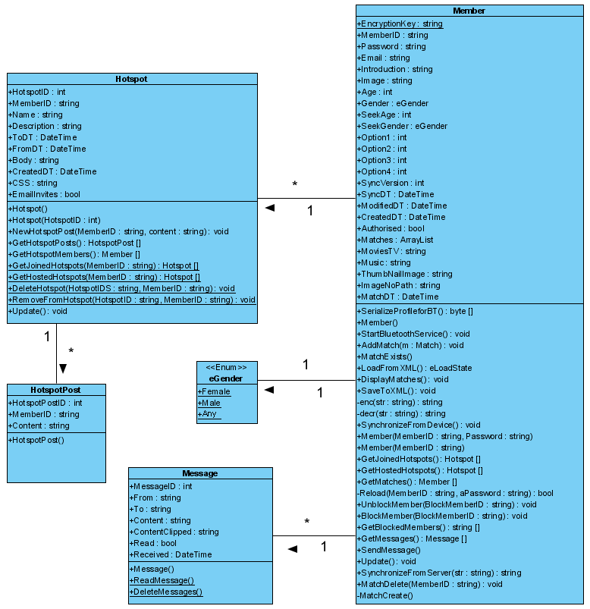

Figure 4.3 UML for the central server

Scripting Language

A scripting language will be introduced to allow algorithms to be displayed. The scripting language, (although not concretely defined in this document) will allow algorithms to be performed on the fly.

An API will allow Node objects with functions and properties to be performed upon.

The following code adds all the nodes to the swarm that were 2 hops away. (The Match object represents a Bluetooth match)

Matches=Match.GetSurroundingNodes(Time=16:00, TimeSpan=20seconds);

Loop through matches with m

Hop2Matches = m.GetSurroundingNodes(Time=16:00, TimeSpan=20seconds)

Loop through Hop2Matches with m2

AddToSwarm(m2)

End loop

End loop

Extended properties and functions of the match object will allow a greater depth or algorithmic precision. For example, additional properties might contain information about a user’s connection quality and camera resolution.

Here is a script to get all users plus all users that are 2 hops away from a specific node (maybe me), have a high resolution camera and have a low internet connection lag

Matches=Match.GetSurroundingNodes(Time=16:00, TimeSpan=20seconds);

loop through matches with m  
  
 //get all the users that are one hop away from all my matches   
 hop1List = m.GetAllMatchesBetween(TimePeriodA, TimePeriodB)  
  
 //add the user to the channel  
 AddCameraToChannel(m)

// loop through all the users that are 2 hop away from m

loop through hop1List with  
         
// if they have a high resolution and lag less than 100ms then add the user to the channel  
if hop1List[i].HasResolution==Resolution.High && hop1List[i].Lag < 100ms   
AddCameraToChannel(hop1List[i))

end loop

end loop  
  
  
So this is an script for a video channel.... When watching a live broadcast of an event users could switch camera views according to the users that are part of the swarm that the algorithm is choosing in real time. Once a user falls out of the swarm by algorithmic disclusion, the video being displayed to the viewer would have the video channel automatically switched to another user who is in the swarm, perhaps the nearest hop, again, algorithm determined.

For a centralized staged event such as a concert where the assumption is that all the cameras are recording the same view space, an algorithm could allow the switching of angles to work over a large range of distances (or hops). This would create a better perspective of the event due to different perspective and work in similar ways to how producers of live TV shows manually switch from camera to camera in a studio.

The following example changes different camera angles between a period of 2 and 7 seconds. On each camera change the view moves further away until the hop reach is 10. After this point the hop count resets to 1.

This sequence of camera changes will move the camera further and further away from a specified user and then suddenly near again... where the algorithm repeat.

While True

If i > 10 then i = 1

Node = getNodesFromNumberOfHopsAway(i++)

Node.ViewCamera();

Sleep for RandomSeconds(between 2 & 7 seconds)

End Loop

Note: Reaching 10 hops and then decrementing backwards would cause the camera angle to move away and then back again, not necessarily through the same path it took.

Further to social networking in a leisure scenario, algorithms could be created for advertising and research corporations who wanted to do mass mining of the swarms over great periods of time and a greater hop depth... think of the possibilities of behavioral patterns we could recognize.... and who might want access to them...Large corps!

For example, in a simple sense, it would be possible to determine a number of people who went out on a Saturday night in Manhattan, how long they were out in bars and restaurants, and what time they came home. Location can be approximated by taking the highest count location property for users. For example, if 20 different matches were made and 15 of the users reside in Manhattan (according to their user profile) then it is likely that the location that all the users were matched in was Manhattan. The higher number of users in the swarm would more accurately approximate location.

The following algorithm returns all the users who are from Manhattan, and got a high number of matches on Saturday night. It also gets all the matches the each of the users obtained. This could allow market researches to determine how many people are visiting a city or place from a specific place and at a specific time span.

UsersOutOnSaturdayNightPartying = NONE

Users GetAllUsersWithLocation(ProfileLocation=”Manhatten”)

Loop though users with u

SaturdayNightMatches = u.GetMatchesBetween(8pm Saturday and 2 am Sunday)

SaturdayNightMatchesFiltered = SaturdayNightMatches.GetMatchesWithMatchCountAbove(20)

UsersOutOnSaturdayNightPartying += SaturdayNightMatchesFiltered + u

End loop

Note: The algorithm could be improved by incorporating a greater depth of hops

User scripts would allow clever algorithms to be created from the framework

Further to this, a library could be created that encapsulates the estimation of distances according to the number of hops and the connection graph of other nodes.

The system comprises of a mobile phone real-time streaming application, a centralized real-time streaming server and a web application server that streams live video and audio feeds to a web browser client encapsulating a multimedia video player such as Macromedia flash , Microsoft’s Silverlight (formerly WPF/E) or similar technologies.

Users of the mobile application are able to record live video streams from the camera in their mobile phone. This is achieved by encoding the video stream into a real time streaming codec and is then streamed to a video server over a real time protocol (RTP) using the mobile phones internet connectivity such as GPRS or WIFI connection. Once the video stream has is being transmitted to the server it is then published to end users who can view the video from within their web browser. This will enable users of the web site to view a mobile stream and view the live video being streamed from the end mobile phone user. The system will allow multiple users to view the same stream.

Two or more users will also be able to utilize the system as a video conferencing model. Such that at least two users will be able to point their mobile phone camera at themselves to transmit video and then view the downlink of the other users stream from within their web browser. This creates a video conferencing environment without the need for video camera hardware to be installed in the client desktop PC.

Further to this, by using a geographical positioning system such as GPS or even Bluetooth technology to pair users who are recording in the same proximity, mobile users’ video streams can be grouped. This will allow users who are recording different video streams in the same vicinity to be grouped together as being at the same “event”. From this point, web browser users will be able to view the group and watch the live streams from the same event. Using the real time protocol will allow web browser users to switch camera views from either of the live streams in the group. This essentially provides different camera angles from the same event in real time.

Users will also be able to create edits of the recorded media and save them for other users to watch. This can be accomplished by taking the duration in seconds for a video stream and the according id of the stream.

**4.4 The device software**

**4.4.1 Overview**

Talk about Movino

**UML Model for mobile device**



Figure 4.4 UML model for the mobile device

# 6 Development practices

**6.1 Source code casing conventions**

Code conventions are a set of simple rules of formatting to follow when writing code. This section could go into great detail regarding the conventions but for the purpose of this report it shall only cover character casings as this is considered one of the most important and uniform levels of code conventions.

It is important to adopt code conventions for the following reasons:

* A large chunk of the lifetime cost of a piece of software goes to maintenance.
* Almost no software is maintained for its whole life by the original programmer.
* Code conventions improve readability and writability of the software allowing engineers to understand new code more quickly and thoroughly and without the need to get to grips with the original programmers style.

**6.3 SQL Server casing conventions**

To reduce database development time, Pascal casing should be used for all table and stored procedure. Although SQL is non-case sensitive the same convention has been used which adds to consistency, readability and writability.

|  |  |  |
| --- | --- | --- |
| **Name for** | **Casing** | **Example** |
| Tables | Pascal | MyTable |
| Stored procedures | Pascal | MyTable |
| All variables in SQL code | Pascal | MyTable |

Table 6.2 – case conventions for SQL server & SQL

Another convention that that the system has adopted is the methodology behind database-object classes instantiation. Since class objects have been mapped to tables in the database they can be instantiated in at least one of two ways: (Using the Member object and database table as an example)

* Member() – creates a blank object to be later inserted into the database
* Member( int MemberID ) – The primary key ID for the database objects is given as a parameter. In this instance a call will be made to the SQL stored procedure GetMember, the values are returned and the object is automatically populated.

**7.4 Source code versioning and backup procedure**

Microsoft SourceSafe [27] is a version controlling source code backup program that allows version controlling within a software development environment. By keeping localised copies of source and resource files on disk and regularly checking in versions of a file allows version control and rolling back of any source code to a milestone point. SourceSafe allows files to be checked in and out avoiding multiple developers changing the file at the same time and overwriting each other’s work.

All files in the system are checked into source safe along with a copy of the database. This is then zipped up and archived in a Google mail account so is it stored elsewhere in case of local development system failure.

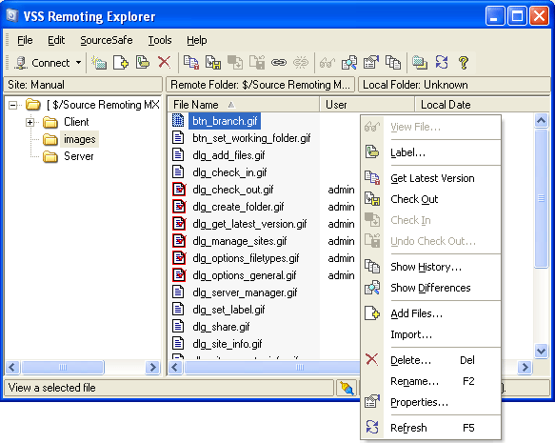

Figure 6.1 – Microsoft Visual Source Safe keeps allows versioning functionality such as code rollback

# 7 Implementation

**7.1 Central web server**

The central server running ASP.NET and makes use of sessions to store client data.

Each page has a header and footer control embedded in the source. This allows changes to be made without making code changes in multiple places. The header control contains code to determine if the users Session[“Member”] object is not null. In the event that it is null, a user has tried to access a page without logging into the system or the client’s session has expired and the system requires that they login again.

**RED5 RTP system**

**7.1.3 Formatting dates**

Dates are displayed on a number of pages throughout the site and it is important to display them in such a way that they can be easily recognised. The PrettyDate() method in the Global class takes a date as an argument and returns a formatted string relative to the current date and time.

For example:

* Today 18:45
* 6 days ago
* Yesterday 14:25

**7.3 Bluetooth communications**

Bluetooth connectivity is handled by two threaded processes:

* Discovery & Send – Looks for new devices and sends the member’s profile
* Listener – Handles incoming connections

The device to initialise connection first acts as the client with the remote device being the server. The client firstly requests connection from the server device using the unique 128 bit GUID. The GUID represents the system protocol identifier and is hard-coded into the device software. Once the client and server have defined that they are running the same protocol the client creates an initialisation string [Figure 8.2].

ALICE AND BOB Example

Figure 7.2 – Example of Bluetooth initialisation string

Upon a succession of the filter process, a Match object is created and added to the member’s match array (also it stored in the XML storage document). Should the device acting as a server implement a client connection whilst or after a match has been made, a check is done on the server to determine if the match already exists. If it does then the match is not added again.

The last byte in the initialisation string is set to 1 if the device has already received the remote user’s profile. This avoids the protocol to keep sending back and forth until the two devices move out of range.

Initially there was a problem with running the discovery agent and the listener at the same time, even in separate threads. However, after investigation, one of the Bluetooth devices used for development did not support multi-way connectivity [5]. This meant that the device could only listen or discover. Consequently, as soon as the code to listen for incoming connections is executed, the program stalls and does not allow Bluetooth discovery until another device moves into range and makes the connection first. This was resolved after installing another Bluetooth device supporting 7-way connectivity. This could mean that the application could be threaded for multiple outgoing and incoming connections at the same time in future releases. It would seem like good practice to leave a few of these channels free however so device users can still use Bluetooth for other scenarios such as headsets.

**7.4 Device storage**

Reading and writing of XML to the device’s disk is achieved through the XmlTextWriter and XmlTextReader class in the System.Xml namespace of the .NET framework.

XmlTextReader takes an XML document file location as a parameter and creates a tree structure of the document in memory. The tree can then be iterated through using the read() method and cascaded down to find the nodes containing information on the stored state of the system. Once the according node has been found it is loaded into memory setting the the device to the state when it was last closed.

The XmlTextWriter class writes XML back to the document with the current state of the server and all matches found. This is achieved with the WriteStartElement() method to create a new node and WriteElementString() to create an element inside the node.

When the application first loads it checks if there is an existing file named goAbout.config.xml. If no file is present then the user will be promted with a screen requesting their member ID and password. The XML storage document is then created and populated with the user’s credentials. The subsequent times the application is loaded, the XML file contents will be automatically loaded with the members details.

**7.3 System security**

This section details the areas of the system which could potentially be exploited. Whilst it is always important to design a system with security in mind some security layers have been implemented after initial design stages. This speeds up development time by not needing to step through code, handling areas such as encryption through prototyping stages.

The following security procedures were implemented in the system

* Username and password verification on device and central server synchronisation
* Encryption of username and password in XML file
* Secure Socket Layer over HTTP for device and central server synchronization
* MAC address verification on device and central server synchronization

**7.3.1 SQL Injection**

When dealing with SQL code it is important to make sure that any SQL code that is being dynamically generated via user input cannot be maliciously compromised. One such malicious technique is called SQL injection. This is where a hacker may place a string in a textbox with intent to “bleed” into the SQL code. For example:

The following code could obtain the requested password through the textbox value. If the value is not the correct password then the query will return a bad login request

|  |
| --- |
| **C# code** |
| SQL = “SELECT * FROM login WHERE password ‘ ” = textbox.text + “ ‘ ”; |
| **Rendered SQL with ‘GBN432JD’ in textbox** |
| SELECT * FROM login where password = ‘GBN432JD’ |

However, a malicious programmer could use a SQL injection technique to change the code to the following:

|  |
| --- |
| **A hackers enters the following text into the textbox:** |
| ‘ or ‘’ = ‘ |
| **Rendered SQL with value from textbox** |
| SELECT * FROM login where password = ‘’ OR ‘’ = ‘’ |

**Result from SQL injection**

Since the OR keyword is used and a blank string is being compared to another blank string, the value will always return either true or all the values from the database.

**Solution**

To evade this problem, stored procedures are used. Apart from the obvious speed and maintainability optimizations, stored procedures are a far more secure way of transferring data between and application and database and also means that SQL code is never compiled into distributable source code.

**8.3.2 Bluetooth MAC address**

When a member synchronises their device with the central server the match MemberID and Bluetooth MAC address are sent. This stops those who have gained access to another member’s ID and password from using the service on their device.

An account shall be temporarily suspended if:

* A user tries connecting using a device with a different MAC address
* A number of attempts are made to synchronise the server with matches that do not exist or have incorrect Mac address (a potential brute force match is taking place)

The Bluetooth MAC address of the mobile device will give power to secure the system in a number of ways: because the MAC address is hardwired into the device it cannot be changed. A malicious user would need to obtain a new mobile device and re-register with the new Bluetooth MAC address. The central system would need to make a number of checks to secure that the any updates to the server come from a device which has the correct member ID and password and has a MAC address paired with the data record on the central server.

**7.3.3 Exploiting stored XML data**

If a handheld device with the system running falls into malicious hands it is important that files cannot be directly read or lifted off the system in their raw format for two reasons:

1. Member ID and password could be extracted and be used to log onto the central web server to take control over the account.
2. Personal settings such as match filter could be viewed.

**Solution**

All data stored in the XML file will be encrypted when written to disk and decrypted after being read. Triple DES [28] encryption is built into the .NET framework and has been used to encrypt and decrypt all XML data.

**7.3.4 Packet sniffing for passwords**

There are a number of ways an unencrypted password or private details can get into the wrong hands when communicating through the internet. One such method is to use packet sniffing software that literally reads the contents of a network packet where passwords can be extracted. *EtherDetect Packet Sniffer* [29] does exactly this and grabs packets that are transmitted over the same network.

**Solution**

Use 128bit Secure Socket Layer. This method allows communication with a high level of encryption that would be very hard to break

**7.3.5 Bluetooth connection block**

It could be possible if someone wrote a custom program to launch a denial of service attack on the goAbout client. A flood of data could be sent to the device tying up all its bandwidth and possibly crashing the device.

**Solution**

Keeps a history of all connections recording MAC address. When a connection is requested a check can be done to see if the device has had any previous connection attempts. If more than a set number exist (in this system’s case 5) then the device drops the connection immediately.

# 8 Testing

**Since only the back end design of the system is to be built, only black box testing will be performed.**

**8.2 White box testing**

A number of command line functions have been called in the system, some of them in batches. This has allowed the development cycle to identify any potential bugs or sub-optimal functions in the system. Some of these tests were successful and identified areas in the system that needed attention. Once such problem that arose from batch execution was SQL server not closing its connections in time and the maximum pool being reached. This was resolved my manually closing the connection and nullifying the connection object.

The full results of all functionality testing can be viewed in section A.6 of the appendix

# 9 System re-evaluation

A survery was performed and people wanted to change

* 10 rated videos/photos
* Make comments
* Customisable profiles

# 10 Final system

Final database design  
Final UML diagram of data layer

# 11 Conclusion

# 12 References

|  |
| --- |
| ***1*** |
| ***Name*** An online dating system with millions of registers members. |
| ***URL****:* <http://www.date.com> |
| ***Author(s)****:* |
| ***Written****:* |
| ***Last Accessed****: 25/04/2006* |

|  |
| --- |
| ***2*** |
| ***Name*** A social networking site that allows users to contact people who are friends of friends. |
| ***URL****:* <http://www.friendster.com> |
| ***Author(s)****:* |
| ***Written****:* |
| ***Last Accessed****: 25/04/2006* |

|  |
| --- |
| ***3*** |
| ***Name*** A similar site to friendster.com. |
| ***URL****:* http://www.myspace.com |
| ***Author(s)****:* |
| ***Written****:* |
| ***Last Accessed****: 25/04/2006* |

|  |
| --- |
| ***4*** |
| ***Name****:* New York city populous. |
| ***URL****:* <http://www.citypopulation.de/USA-NewYork.html> |
| ***Author(s)****:* |
| ***Written****:* |
| ***Last Accessed****: 25/04/2006* |

|  |
| --- |
| ***5*** |
| ***Name****:* The official Bluetooth consortium device specifications: *Bluetooth* SIG, Inc. - 2005-03-16 |
| ***URL****:* <http://www.bluetooth.org/foundry/adopters/document/Bluetooth_Specification_Guidelines/Bluetooth_Specification_Guidelines.pdf> |
| ***Author(s)****:* |
| ***Written****:* |
| ***Last Accessed****: 25/04/2006* |

|  |
| --- |
| ***6*** |
| ***Name****:* Mobile device operating system developed by Ericsson, Nokia, Panasonic, Samsung, Siemens and Sony. |
| ***URL****:* <http://www.symbian.com/about/ownership.html> |
| ***Author(s)****:* |
| ***Written****:* |
| ***Last Accessed****: 25/04/2006* |

|  |
| --- |
| ***7*** |
| ***Name****:* The Microsoft smartphone device running the .NET compact framework. |
| ***URL****:* <http://www.microsoft.com/windowsmobile/smartphone/default.mspx> |
| ***Author(s)****:* |
| ***Written****:* |
| ***Last Accessed****: 25/04/2006* |

|  |
| --- |
| ***7*** |
| ***Name****:* Microsoft’s’ Compact framework home page |
| ***URL****:* <http://msdn.microsoft.com/smartclient/understanding/netcf> |
| ***Author(s)****:* |
| ***Written****:* |
| ***Last Accessed****: 25/04/2006* |

|  |
| --- |
| ***8*** |
| ***Name****:* *Antero Taivalsaari,* a developer for Sun Microsystemstalks about the future of J2ME in mobile devices. |
| ***URL****:* <http://developers.sun.com/techtopics/mobility/midp/luminaries/taivalsaari> |
| ***Author(s)****:* |
| ***Written****:* |
| ***Last Accessed****: 25/04/2006* |

.

|  |
| --- |
| ***19*** |
| ***Name****:* MAC Address information |
| ***URL****:* <http://www.webopedia.com/TERM/M/MAC_address.html> |
| ***Author(s)****:* |
| ***Written****:* |
| ***Last Accessed****: 25/04/2006* |

|  |
| --- |
| ***10*** |
| ***Name****:* J2ME - Suns’ equivalent to Microsoft .NET compact framework |
| ***URL****:* <http://java.sun.com/j2me/index.jsp> |
| ***Author(s)****:* |
| ***Written****:* |
| ***Last Accessed****: 25/04/2006* |

.

|  |
| --- |
| ***11*** |
| ***Name****:* A mobile Bluetooth messaging system targeted at the dating scene. |
| ***URL****:* <http://www.proxidating.com> |
| ***Author(s)****:* |
| ***Written****:* |
| ***Last Accessed****: 25/04/2006* |

|  |
| --- |
| ***12*** |
| ***Name****:* MeetingPlace – Another Bluetooth messaging system for mobile devices. |
| ***URL****:* <http://www.bedd.com/about.html> |
| ***Author(s)****:* |
| ***Written****:* |
| ***Last Accessed****: 25/04/2006* |

|  |
| --- |
| ***13*** |
| ***Name****:* A multi-purpose mobile Bluetooth client/server for mobile devices. |
| ***URL****:* <http://www.bedd.com/about.html> |
| ***Author(s)****:* |
| ***Written****:* |
| ***Last Accessed****: 25/04/2006* |

|  |
| --- |
| ***14*** |
| ***Name****:* A network of members to chat and rate each other according to their photo. |
| ***URL****:* <http://www.facethejury.com> |
| ***Author(s)****:* |
| ***Written****:* |
| ***Last Accessed****: 25/04/2006* |

|  |
| --- |
| ***15*** |
| ***Name****:* The home site for Suns’ Java virtual machine and framework. |
| ***URL****:* <http://java.sun.com/> |
| ***Author(s)****:* |
| ***Written****:* |
| ***Last Accessed****: 25/04/2006* |

|  |
| --- |
| ***16*** |
| ***Name****:* An open source web application language and platform. |
| ***URL****:* <http://www.php.net/> |
| ***Author(s)****:* |
| ***Written****:* |
| ***Last Accessed****: 25/04/2006* |

|  |
| --- |
| ***17*** |
| ***Name****:* A dynamic web application language and platform with html like syntax. |
| ***URL****:* <http://www.macromedia.com/software/coldfusion/> |
| ***Author(s)****:* |
| ***Written****:* |
| ***Last Accessed****: 25/04/2006* |

|  |
| --- |
| ***18*** |
| ***Name****:* The home page for Microsoft classic ASP language. |
| ***URL****:* <http://www.asp101.com/> |
| ***Author(s)****:* |
| ***Written****:* |
| ***Last Accessed****: 25/04/2006* |

|  |
| --- |
| ***19*** |
| ***Name****:* Bluetooth support for windows XP (SP1 and forward). |
| ***URL****:* <http://msdn.microsoft.com/library/default.asp?url=/library/en-s/bluetooth/bluetooth/about_bluetooth.asp>. |
| ***Author(s)****:* Peter Foot |
| ***Written****: 7/10/2004* |
| ***Last Accessed****: 25/04/2006* |

|  |
| --- |
| ***20*** |
| ***Name****:* OpenNetCF - An open source extended framework for the compact framework with support for Bluetooth. |
| ***URL****:* <http://www.opennetcf.org/CategoryView.aspx?category=Home> |
| ***Author(s)****:* Peter Foot |
| ***Written****: 7/10/2004* |
| ***Last Accessed****: 25/04/2006* |

|  |
| --- |
| ***21*** |
| ***Name****: In The Design and Evolution of C++* |
| ***URL****:* [*N/A*](http://www.disordered.org/Java-QA.html) |
| ***Authors****:* Bjarne Stroustrup |
| ***Written****: 1994* |
| ***Last Accessed****: 25/04/2006* |

|  |
| --- |
| ***22*** |
| ***Name****: Improving a human-computer dialogue,* Communications of the ACM |
| ***URL****:* [*N/A*](http://www.disordered.org/Java-QA.html) |
| ***Author(s)****: Molich, R.and Nielsen, J* |
| ***Written****: 3/3/1990* |
| ***Last Accessed****: 25/04/2006* |

|  |
| --- |
| ***23*** |
| **Name**: Java and C++ execution speed |
| **URL**: <http://www.disordered.org/Java-QA.html> |
| ***Author(s)****:* [*Hank Shiffman*](mailto:hank@disordered.org) |
| ***Written****: 6/3/2004* |
| ***Last Accessed****: 25/04/2006* |

|  |
| --- |
| ***24*** |
| ***Name****: Greenbergs CRAP framework* |
| ***URL****:* [*http://pages.cpsc.ucalgary.ca/~saul/581/presentations/05-crap/*](http://pages.cpsc.ucalgary.ca/~saul/581/presentations/05-crap/) |
| ***Author(s)****: Saul Greenberg, Professor. Human-Computer Interaction & Computer Supported Cooperative Work. Department of Computer Science University of Calgary* |
| ***Written****: 22/4/2003* |
| ***Last Accessed****: 25/04/2006* |

|  |
| --- |
| ***25*** |
| ***Name****: VMware’s* Virtual serversftware |
| ***URL****:* http://www.vmware.com/pdf/vi_brochure.pdf |
| ***Author(s)****: VMWare* |
| ***Written****: 04/11/2005* |
| ***Last Accessed****: 25/04/2006* |

|  |
| --- |
| ***26*** |
| ***Name****: Latest version of SOAP Version 1.2 specification: Martin Gudgin, Microsoft* |
| ***URL****:* [*http://www.w3.org/TR/soap12*](http://www.w3.org/TR/soap12) |
| ***Author(s)****: Marc Hadley, Sun Microsystems, Noah Mendelsohn, IBM, Jean-Jacques Moreau, Canon, Henrik Frystyk Nielsen, Microsoft* |
| ***Written****: 24/6/24/2003* |
| ***Last Accessed****: 25/04/2006* |

|  |
| --- |
| ***27*** |
| ***Name****: Microsoft Source safe code repository* |
| ***URL****: http://msdn.microsoft.com/vstudio/previous/ssafe/productinfo/overview/* |
| ***Author(s)****: N/A* |
| ***Written****: Unknown* |
| ***Last Accessed****: 25/04/2006* |

|  |
| --- |
| ***28*** |
| ***Name****:Triple DES encryption standards* |
| ***URL****: http://en.wikipedia.org/wiki/Triple_DES* |
| ***Author(s)****: N/A* |
| ***Written****: Unknown* |
| ***Last Accessed****: 14/04/2006* |

|  |
| --- |
| ***29*** |
| ***Name****: EtherDetect Packet Sniffer – packet sniffing software for network password extraction* |
| ***URL****:* <http://www.etherdetect.com> |
| ***Author(s)****: N/A* |
| ***Written****: Unknown* |
| ***Last Accessed****: 12/04/2006* |

# Appendix

**1.0 Background**

Introduction to existing video streaming sites and concepts (IE.. BBC news have been doing this for years)

The next section critiques existing products and services. This will allow the system to evolve the concept and practicalities and take parts from other existing services that are useful and relevant.

YouTube.com

**

**Livevideo.com**

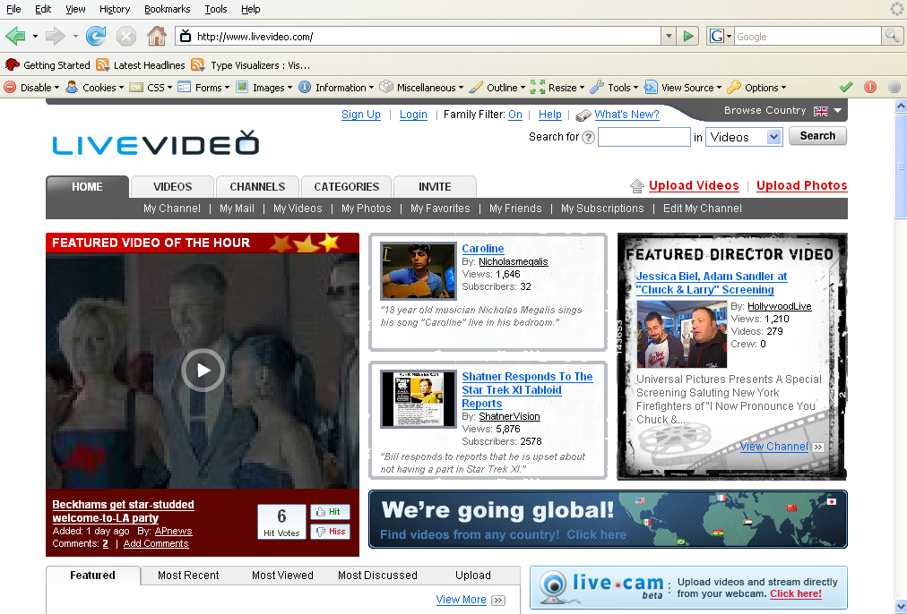

**Video.google.com**

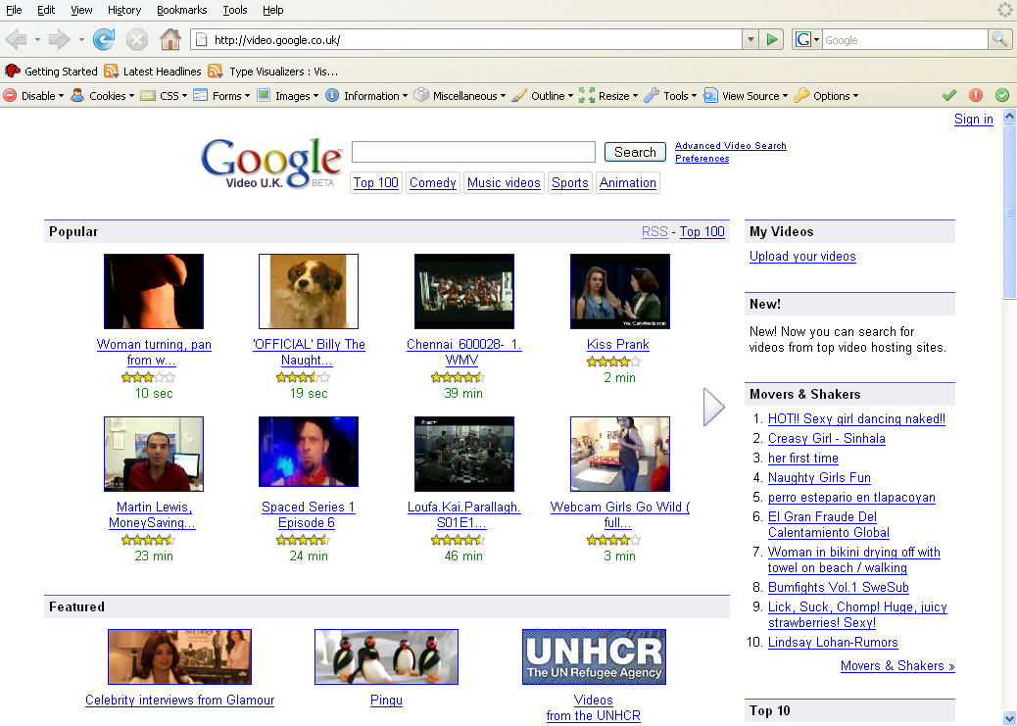

**Veoh.com**

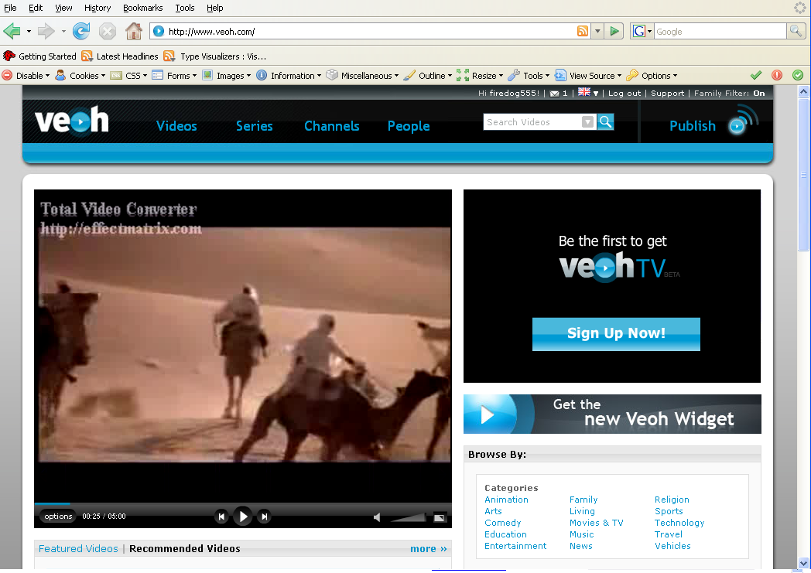

Next2Friends Scenarios **Street/Subways**

Jadon is a 25 year old single guy who just moved to LA to start a new web development job. He has been working some long hours since he moved to the city and has found it hard to meet people in his area, the city can feel unfriendly at times. One morning Jadon sets off to work, its 10 minutes walk to the subway and then a further 14 minutes on the tube. Jadon sets grabs his wallet, keys and mobile phone loaded with the nextoFriends service and leaves his house. He makes his way past a few stores, including a skate shop and a book store before jumping on a person-packed subway train.

He arrives at work to find an email in his inbox notifying him that he has some new friend matches. He didn’t want to match everyone he came across so he set the matching filter to girls and guys aged 22-28 and added a few preferential filter options, including “punk rock” and “artistic” as well as setting “new to the area” option. Jadon knows he is at work but he cannot resist to view the profiles of his new matches. Jadon clicks the link in the email and is logged into his nextoFriends.com account where he is presented with a couple of friend matches.   
  
Lola 23 – A graphic designer just moved in from Illinois looking to make some new friends  
Sabin 25 – A local skater guy, enjoys spray paint tagging and punk music  
  
He thinks:  
  
*“Lola’s pretty cute and she’s probably at work right about now. I’ll send her a message and see if she wants to check out some new places in LA this weekend.”*

**

# Bars & Clubs

Halona is single girl of 22 years, she is a college graduate and enjoys spending her time in bars and clubs with her girl friends. One Saturday night, she and her friends hit the town for a new drinks and a catch up, all of her friends are running the nextoFriends service on their (quite stylish and pretty extensive) mobile devices/accessory. They drop in on a few bars which are crowded with other youngster also running the service on their mobiles. As the night progresses the bluetooth service quietly tags others around them and sends the tag certificates to the server securely. Halona and her friend’s record video onto their phones of their slightly drunken antics and by then end of the evening, between them they have taken over 117 photos.

The next day Halona wakes up (slightly hung-over) and decides to log onto her nextoFriends.com account. Firstly, she is greeted with an indication that she and her (already established) friends have been allocated a hotspot and automatically generated bundles of chronologically ordered photos and videos. She laughs as she flicks through some of the photos from the night before. She then grabs herself a coffee and requests a system generated video edit of the night. She is displayed with a 20 video from all the girls cameras starting from the first bar they were in to the cab they got home.

She then notices that she has made a number of new friends via Bluetooth friend-tagging and in fact a message from one, a guy that she briefly made eye contact with in a bar:

*Hey how’s it going!   
I saw you in Sinatra’s last night. I was going to come and say hello to you but my buddies wanted to go to another bar. So are you from London? Message me back!*

*Nazario*

Diagram for this scenario

# 

# Weddings

It was Espan & Malin’s wedding. They decided to hire a photographer for all the high profession photos and use the nextoFriends.com service to organize and document all the invitees photos and videos from their mobile phones. Espan added a number of the wedding guests (Mum, Dad, brother, and the best man) to a list of hotspot owners, so as they experience the wedding they tag other guests and make them part of the hotspot. Over the period of 8 hours the ceremony and reception had over 2,000 photos and 183 videos to its merit. Since all the wedding guests were tagged via the Bluetooth service in the phones when their media is uploaded it is automatically catalogued and organized within the *“Espan & Malin’s wedding”* hotspot.

The next day all the wedding guests receive and email notifying them of the wedding hotspot, (some couldn’t resist the wait and had logged on already). As guests view the photos and videos, they rate them from 1-5 and add comments. After 10 visits, the hotspot starts ordering its media via its popularity driven from user click, comments and ratings scored. The home page has a top 20 photos and videos and even allows the day to be view by an automated video edit of videos.

Espan & Malin were so thrilled with the day they decided to leave a message for everyone on the Channel to see:

*Thank You all for coming to our wedding*

*It was the greatest day of our lives and we are so happy that we could share it with you*

*Espan & Malin*

A few weeks later Espan logs onto his nextoFriends.com account and using the flash video editor puts together a well thought-out video edit of the wedding and places some custom graphics in the title shot. He, adds all his wedding guests addresses into the system and orders 200 copies of the wedding video on DVD and has all the copies made and shipped directly to the wedding guests. It cost $2,000 for 200 copies with case and color art but it’s the least they could do considering the event, not to mention all the gifts the newlyweds received.

**Create Diagram for Weddings**

# Event/group Meets

The *Sunshine coast radio controlled car club* is just what is says it is and it even has a web site (<http://www.scrccc.com>). Once a week its 134 members of the club meet up to race their finely tuned model cars with precision driving skills. It’s a competitive sport with all the glory and shame of F1. Over the course of a day, 25 races take place until at the by the there is only one winner, and what a win it was!. Over 20 mobile phones captured the event, all running the nextoFriends service.

That evening as the club member arrive at home they log onto their nextoFriends.com account and notice that they are a member of a hotspot. “*The Sunshine coast radio controlled car club – August 23rd Rally”*

As comments and ratings are posted on the hotspot page, the photos and video are organized and the most popular or relevant media is displayed in features items and the hotspot home page. Several days of banter is exchanged in the form of comments underneath the media items.

One comment list reads:

***Dan Wrote at yesterday at 10:23pm****Pure luck my friend.. You won by a nose hair! Next Time!*

***Mike Wrote at yesterday at 11:47pm***

*Haha.. yeah right! With that piece of crap car!  
You’ll never catch me! I am unbeatable!!*



Change the above diagram for Radio Controlled cars

# Live TV channels

Bellona is a 16 year old girl from a small town in Florida. Only a few months ago she was a YouTube addict, recording video diary entries for her 1,851 subscribers which are watched by 21,578 people a month. The only trouble is, a lot of cool and fun stuff happens outside of her bedroom and away from her webcam, she doesn’t own a portable video camera and if she did she wouldn’t want to carry it around with her all day in the event that she was inspired to make an adhoc video diary entry. She’s also is limited to people watching the video only after it has finished being recorded which could be as long 15 minutes!

Now a days she uses the nextoFriends Live! Service. She is able to grab her mobile device at any time of day and with a press of a hotkey on the phone she is recording live video to her nextoFriends account. Her fanatical subscribers are informed by email that a live broadcast is taking place and within minutes she has 137 people view her live video. For those who missed the show, there will be a stored video on her “Channel” page that they can view at a later time. This way she is not only able to record her videos anytime and anywhere but her viewers can watch the live broadcast in real time. She can also record for as long as she wishes, unlike YouTube who impose a limit of 15 minute on all video lengths.

As an incentive for Bellona to keep making high quality and frequent videos, nextoFriends.com allows paid advertising to be embedded in her live and pre-recorded videos. Bellona can choose from categories and keywords that will allow tailored commercial ads to be shown to users at the beginning of the video and intermittently every 2-3 minutes. She will then receive cash for all the ads shown and even more if a user clicks –through to ad vendors web site. She also takes advantage of intelligent algorithm that automatically cross references the behaviors and likes of her viewers so every single person who watches her video will be delivered a personalized commercial that combines the relevancy of her video and their own individual habits.

She and her friends have talked about creating a series of shows that have a designated slot. Her nextoFriends premium account allows her to schedule her videos and allow them only be viewed after a specific time and day. She feels its just like her own TV channel.



# Live video conferencing via Web

Enaco is 21 year old student from Italy. If he is not studying in his bedroom he at his job or in the labs at college. One afternoon Enaco is in computer room BS1, writing his essay, he logs onto his

nextoFriends.com account and minimizing the browser and gets writing for his assignment. After about 45 minutes of work his browser bleeps and displays a message notifying him that his buddy Sanez is calling him. He maximizes his browser and accepts the connection, he then picks up his phone and after flicking the *accept call* hotkey he places his phone on the desk pointing towards him. Sanez’s face appears in a video window of the web page and he begins to speak. Sanez is also now setup so he too can see Enaco’s face and hear him talk in real-time, all broadcasted via their mobile devices. They have a quick catch-up and talk about going to a party that evening on campus before ending the video call.

Later that day, Enaco arrives at home he logs onto nextoFriends.com, selects Sanez’s nickname from the his buddy list and calls him to arrange the evening. They both video chat for 20 minutes then arrange to meet at 9:00 at the party.



# Scripting

Mike is a junior computer programmer from New York. He works for a small insurance company creating simple office applications in visual basic. Mike is also a nextoFriends premium member which allows him to create and sell custom scripts for other users to buy. Scripts are simple programs that run inside the nextoFriends system and allow members to automatically cross reference their matches. Details in their matches such as Date of Match, total number of matches in a matches, interests and even use information about the people who matched his own matches are used in the script.   
  
Additionally, he can write video scripts that can be used when watching recorded or live videos. These scripts create user experience by switching camera angles according to the Bluetooth network shape of members video in one hotspot. This emulates a TV-like experience with an Artificially intelligent director, with Mikes code making the video cuts and dynamically adding suitable video effects. The script can also control details such as the member minimum camera phone resolution, and internet connection latency.

Mike has programmed a number of languages and the nextoFriends scripting language is one of the simplest to use. He wrote one script that returns all the live video feeds that matched the hotspot hoster plus all member that are 2 hops away from a hotspot hoster, have a 640 X 480 camera resolution and have a low internet connection lag   
  
Matches=Match.GetSurroundingNodes(Time=16:00, TimeSpan=20seconds);

loop through matches with m

//get all the users that are one hop away from all my matches   
hop1List = m.GetAllMatchesBetween(TimePeriodA, TimePeriodB)  
  
//add the user to the channel  
AddCameraToChannel(m)  
  
 // loop through all the users that are 2 hop away from m

Loop through *hop1List* with  
  
// if they have a high resolution and lag less than 100ms then add the user to the channel  
if hop1List[i].HasResolution==Resolution.640X480 && hop1List[i].Lag < 100ms

AddCameraToChannel(hop1List[i))  
end loop

end loop

end loop

Members are not able to view the source of his scripts and this allows him to make clever things happen without other people copying his ideas. The above script has sold over 4,546 in the last month. The commission he earns from the sale of his scripts allows him to keep making new and better ones with more complex functions and greater creative imagination.

**A.9 Management**

**A.9.1 Reading & Research:**

Sams J2ME

Wrox XML

MSDN online Library

Wrox C# data security

**A.9.2 Programming web sites**

[http://msdn.microsoft.com/library/default.asp?url=/library/en-s/bluetooth/bluetooth/ about_bluetooth.asp](http://msdn.microsoft.com/library/default.asp?url=/library/en-s/bluetooth/bluetooth/%20about_bluetooth.asp)

<http://www.opennetcf.org/CategoryView.aspx?category=Home>

**A.9.3 Other systems examined**

The following systems were examined and evaluated to pick out the fine and useful points. This has then been used to determine the functionality and usability of my system.

* <http://www.date.com> - An online dating system with millions of registers members.
* <http://www.friendster.com> - A person networking site that allows users to contact people who are friends of friends.
* <http://www.hi5.com> - A similar site to friendster.com.
* <http://www.net-cell.com/MP/index.html> - MeetingPlace – Another Bluetooth messaging system for mobile devices.
* <http://www.bedd.com/about.html> - A multi-purpose mobile Bluetooth client/server for mobile devices.
* <http://www.facethejury.com> - A network of members to chat and rate each other according to their photo.

**A.9.4 Interim log:**

* ????

**A.9.5 project plan Gantt chart**

The project plan can be viewed in the appendix under section A.9.6